16)

(A)

CREATE TABLE STUDENT (

RegisterNumber INT PRIMARY KEY,

StudentName VARCHAR(50),

Age INT,

Major VARCHAR(50)

);

-- Insert data into STUDENT table

INSERT INTO STUDENT (RegisterNumber, StudentName, Age, Major)

VALUES

(191711342, 'John Doe', 20, 'Computer Science');

INSERT INTO STUDENT (RegisterNumber, StudentName, Age, Major)

VALUES

(191711343, 'Jane Smith', 21, 'Mathematics');

CREATE TABLE FACULTY (

EmployeeID INT PRIMARY KEY,

FacultyName VARCHAR(50),

Department VARCHAR(50),

Resigned DATE

);

-- Insert data into FACULTY table

INSERT INTO FACULTY (EmployeeID, FacultyName, Department, Resigned)

VALUES

(1001, 'Professor Johnson', 'Physics', '2023-03-15');

INSERT INTO FACULTY (EmployeeID, FacultyName, Department, Resigned)

VALUES

(1002, 'Dr. Williams', 'Chemistry', '2022-08-20');

CREATE TABLE COURSE (

CourseCode VARCHAR(10) PRIMARY KEY,

CourseName VARCHAR(100),

Department VARCHAR(50)

);

-- Insert data into COURSE table

INSERT INTO COURSE (CourseCode, CourseName, Department)

VALUES

('CSC101', 'Introduction to Programming', 'Computer Science');

INSERT INTO COURSE (CourseCode, CourseName, Department)

VALUES

('MAT202', 'Calculus II', 'Mathematics');

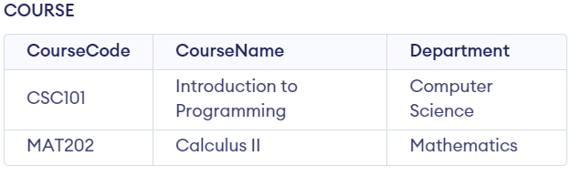

CREATE TABLE ENROLLMENT (

RegisterNumber INT,

CourseCode VARCHAR(10),

Grade CHAR(2),

PRIMARY KEY (RegisterNumber, CourseCode),

FOREIGN KEY (RegisterNumber) REFERENCES STUDENT(RegisterNumber),

FOREIGN KEY (CourseCode) REFERENCES COURSE(CourseCode)

);

-- Insert data into ENROLLMENT table

INSERT INTO ENROLLMENT (RegisterNumber, CourseCode, Grade)

VALUES

(191711342, 'CSC101', 'A');

INSERT INTO ENROLLMENT (RegisterNumber, CourseCode, Grade)

VALUES

(191711342, 'MAT202', 'B');

CREATE TABLE DEPARTMENT (

DepartmentName VARCHAR(50) PRIMARY KEY,

HeadOfDepartment VARCHAR(50)

);

-- Insert data into DEPARTMENT table

INSERT INTO DEPARTMENT (DepartmentName, HeadOfDepartment)

VALUES

('Computer Science', 'Dr. Smith');

INSERT INTO DEPARTMENT (DepartmentName, HeadOfDepartment)

VALUES

('Mathematics', 'Professor Brown');

(B)

UPDATE STUDENT

SET StudentName = 'Updated Name'

WHERE RegisterNumber = 191711342;

(C )

DELETE FROM FACULTY

WHERE Resigned IS NOT NULL;

